20k scanner set

User manual

Potentiometer description:  
• IS Input scale (adjusted only in factory)   
• SG Servo gain (power of the feedback signal for internal PID controller   
• LFD Low frequency damping (correct overshoot)   
• HFD High frequency damping (correct undershoot)   
• LIN Zero offset (electrical offset of the driver, adjusted only in factory)   
• PS Position scale (increases or decrease input sensitivity of the computer, DO NOT change it)  
These pots aren’t marked  
To be able to tune you need to know which pot on the board is which  
As I could randomly adjust the wrong pot without this knowledge   
Ie(electrical offset of the driver, adjusted only in factory)

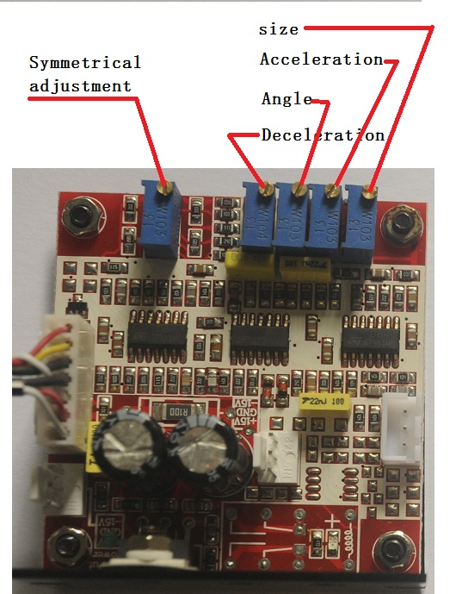



sensitivity

MIC

Mode set

Ilda input

+/-15V input

Blue TTL Green TTL Red TTL Y+/Y-/G X+/X-/G size DMX

Set laser show work mode

|  |  |  |  |  |  |  |  |  |  |  |
| --- | --- | --- | --- | --- | --- | --- | --- | --- | --- | --- |
| **Address(1=ON 0=OFF)** | | | | | | | | | | **Mode** |
| **1** | **2** | **3** | **4** | **5** | **6** | **7** | **8** | **9** | **10** |  |
| **0** | **0** | **0** | **0** | **0** | **0** | **0** | **0** | **0** | **1** | Audio mode |
| **1** | **0** | **0** | **0** | **0** | **0** | **0** | **0** | **0** | **1** | Auto mode |
| **0** | **0** | **0** | **0** | **0** | **0** | **0** | **1** | **0** | **1** | Audio cartoon mode |
| **0** | **0** | **0** | **0** | **0** | **0** | **0** | **0** | **1** | **1** | Audio pattern |
| **1** | **0** | **0** | **0** | **0** | **0** | **0** | **0** | **0** | **1** | Auto cartoon |
| **1** | **0** | **0** | **0** | **0** | **0** | **0** | **0** | **1** | **1** | Auto pattern |
| Set dmx address code | | | | | | | | | **0** | DMX/slave mode |

|  |  |  |
| --- | --- | --- |
| **Channel** | DMX512 | **Function** |
| **1．Laser control mode** | **0-63** | **Shut up** |
| **64-127** | **Audio** |
| **128-191** | **Auto** |
| **192-255** | **DMX** |
| **2. Pattern** | **0-163** | **More than 100 pattern** |
| **164-255** | **Cartoon pattern** |
| **3.color** | **0---1** | **W** |
| **2--9** | **R** |
| **10---19** | **G** |
| **20--29** | **B** |
| **30--39** | **RG** |
| **40--49** | **RB** |
| **50--59** | **GB** |
| **60--69** | **RGB** |
| **70--79** | **R-G-B 3 color divided** |
| **80--89** | **RG-RB-GB 3 color divided** |
| **90--99** | **R-G-B-RG-RB-GB-RGB 7 color divided** |
| **100--109** | **R-G-B-RG-RB-GB-RGB Color flow** |
| **110-119** | **R-G-B 3 color divided** |
| **120--129** | **RG-RB-GB 3 color divided** |
| **130--139** | **R-G-B-RG-RB-GB color divided** |
| **140--179** | **R-G-B auto choice** |
| **180--219** | **RG-RB-GB auto choice** |
| **220-255** | **R-G-B-RG-RB-GB-RGB auto choice** |
| **4.X position** | **0---127** | **manual adjustment** |
| **128--160** | **Move Left** |
| **161--192** | **Move right** |
| **193--224** | **Move left or right** |
| **225--255** | **Jumping around** |

|  |  |  |
| --- | --- | --- |
| **5.Y position** | **0--127** | **manual adjustment** |
| **128--160** | **Move down** |
| **161--192** | **Move up** |
| **193--224** | **Move up or down** |
| **225-240** | **Jumping around** |
| **241-255** | **Square trajectories** |
| **6 X axis gradient** | **0--150** | **Manual morphing** |
| **151--255** | **Automatic morphing** |
| **7 Y axis gradient** | **0--150** | **Manual morphing** |
| **151--255** | **Automatic morphing** |
| **8 Rotator** | **0---180** | **Manual rotation** |
| **181—224** | **Automatic Anticlockwise rotation** |
| **225--255** | **Automatic clockwise rotation** |
| **9.zoom** | **0---10** | [**normal**](http://dict.baidu.com/s?wd=normal) |
| **11—115** | **Manual zoom** |
| **116--170** | **Auto big** |
| **171--210** | **Auto small** |
| **211--255** | **Auto zoom** |
| **10. Sine wave** | **0--127** | **Level fluctuation** |
| **128--255** | **vertical fluctuation** |
| **11.Display mode** | **0---63** | [**normal**](http://dict.baidu.com/s?wd=normal) |
| **64--127** | **Shining point display** |
| **128--191** | **Section line display** |
| **192--255** | **Point display** |
| **12.Gradually drawing** | **0--64** | **Manual gradually drawing** |
| **65--127** | **Forward gradually drawing** |
| **128--191** | **Reverse gradually drawing** |
| **192--255** | **positive and negative automatic gradually drawing** |
| **13 Pattern**  **Move mode** | **0—255** | **Select two different motion pattern** |
| **14（Double pattern mode） Second pattern choice** | **0—203** | **Same CH2** |
| **15（Double pattern mode） Second pattern color choice** | **0--255** | **Same CH3** |